STATEMENT OF WORK UPS SYSTEM MAINTENANCE
FOR

WESTERN AREA POWER ADMINISTRATION DESERT SOUTHWEST REGION
PHOENIX CAMPUS
July 9, 2026

CONTENTS

- INTRODUCTION/OBJECTIVE

- QUALITY ASSURANCE SURVEILLANCE PLAN (QASP)
- SCOPE OF SERVICES
- ACCESS AND RESTRICTIONS

- UTILITIES

- SAFETY

- PICTURES

1.0 INTRODUCTION/OBJECTIVE
  - The purpose of this Statement of Work (SOW) is to establish the requirements for the inspection, testing, preventive maintenance, and repair services of the Uninterruptible Power Supply (UPS) systems at Western Area Power Administration (WAPA) facilities. The UPS systems are critical infrastructure components designed to ensure continuous, reliable power to essential equipment and operations in the event of power disturbances or outages.

  - The objective of this effort is to maintain optimal performance, reliability, and longevity of all UPS equipment through scheduled preventive maintenance and timely corrective actions. Services shall include routine inspections, system diagnostics, battery testing, load testing, cleaning, calibration, and necessary repairs or component replacements. The contractor shall identify and mitigate potential issues before failure occurs, minimizing downtime and operational risk.

  - This SOW also aims to ensure compliance with applicable safety standards, manufacturer recommendations, and industry best practices. All work performed shall support WAPA’s mission by ensuring uninterrupted power availability, safeguarding critical systems, and maintaining a safe and efficient operating environment.

1.4 The Contractor is to contact DSW federal employee Timothy Hurst (COR) at (602) 615-2509 or hurst@wapa.gov, to verify that the site is ready for the performance of work as set forth in this SOW, to coordinate arrival time to allow a WAPA representative to meet and escort the contractor while on DSW property. The contractor is not permitted to work on-site without the presence of a WAPA representative. Work must be performed Monday through Friday between the hours of 6:30am – 3:00pm. Work performed outside of these hours must be coordinated and approved 48 hours in advance by the COR.

Quality Assurance Surveillance Plan (QASP)

  - The Performance Requirements Summary (PRS) is a listing of the significant performance objectives with associated performance standards that will be monitored and inspected by the Government. The performance standard represents the minimum acceptable level of Contractor performance. The performance objectives and standards represent only the critical components of this Contract and do not excuse the Contractor from performance of other responsibilities identified in the PWS.

  - ​The PRS indicates the services of the Contractor that the Government will evaluate to report the Contractor meets standards of performance. The purpose of the PRS is to identify the levels of performance required to warrant full payment. The absence of any contract requirement from the PRS shall not detract from its enforceability or limit the rights or remedies of the Government under any other provision of the contract, including the "Inspection of Services" clause in determining the quality of Contractor performance. Other tasks identified in the SOW but not identified as a PRS may be added for surveillance at any time as determined by the CO.

  - A Contractor Discrepancy Report (CDR) is prepared by the COR when the Contractor exceeds the Allowable Acceptable Quality Level. The COR shall submit the CDR, along with supporting documentation, to the CO. Upon the CO’s validation of the CDR, the CO will approve the document and send it to the Contractor for their action. Once all conditions of the CDR are met, the CO will file as an official record to document contract Performance. If the contractor is required to repeat the required performance or action correctly the CDR will remain open until the services have been determined complete. If the services cannot be re-performed or completed, then a monetary deduction will be taken based on the position assigned to the task and estimated number of hours to complete the task.

PRS  Item # | Quantity | Agreement Type | Description of Equipment and Serial Number(s) | PM  Frequency | Billing Frequency | 100%  Contractor is not allowed any deviation | Surveillance: Government Inspection, Complaints | Contractor may not exceed more than 2 CDR’S  Quarterly
 |  |  |  |  |  | “ | “ | “
1. | 1 | PM | Toshiba UPS SN#  23530353 | 4 | 1 | “ | “ | “
2. | 1 | PM | Toshiba UPS SN#  22530161 | 4 | 1 | “ | “ | “
3. | 120 | PM | C&D 4XTLC-  15 Batteries | 4 | 1 | “ | “ | “
4. | 96 | PM | BAE 12OPzS 1500 LA  DIN 40736-1 | 4 | 1 | “ | “ | “
5. | 1 | PM | Cyberex STS SN: 27482-  1-1 | 4 | 1 | “ | “ | “
6. | 1 | PM | Cyberex STS SN: 27482-  2-1 | 4 | 1 | “ | “ | “

Scope of Services
  - Personnel: The contractor shall provide manufacturer certified, qualified, trained, skilled personnel for the testing and preventative maintenance (per the manufacturer) of the following equipment manufactures listed below for each Toshiba UPS unit model T90S3S16KS6XSN2, Cyberex static Transfer switch model, Super Switch3, and flooded battery system: Technical support from a certified technician for preventative maintenance service to two (2) UPS Systems.

  - Service Plan (Toshiba T90S3S16KS6XSN2) (160 kVA) (24/7 coverage): All parts, labor, and travel expenses associated with preventative/corrective maintenance of the equipment is at the cost of the Contractor. Maintenance procedures include preventive maintenance, isolation procedures for maintenance, startup for single and parallel units after isolation, functional and visual checks, software options and configurations, and testing scenarios. The Contractor must provide a written quote and gain approval by the COR before any repair or replacement of any items upon deficiencies assessment. Conduct one (1) PMI per unit Quarterly following prior PMI schedules. This service does not include AC and DC Cap Replacement. The Contractor will be provided a detailed summary report of each PMI within seven (7) days.

  - ​Service Plan (Cybertex, Super Switch3 (STS)) (400 amp) (24/7 coverage): All parts, labor, and travel expenses associated with preventive/corrective maintenance of the equipment is at the cost of the Contractor. This system shall be inspected for electrical connection integrity, signs of excessive temperature, accumulation of dirt, and proper system operation. Conduct one (1) PMI per unit Quarterly following prior PMI schedules. The Contractor will be provided a detailed summary report of each PMI within seven (7) days.

  - Service Plan (C&D 4XLT-C15 Batteries): Perform quarterly PMIs on the batteries listed in Table 1. At a minimum, the Contractor will measure cell voltage levels, check batteries for loose connection, test cell/unit internal ohmic value and visually inspect for battery leakage, swelling, corrosion as well as the battery environment. The Contractor will provide a detailed report with the results of the inspection and recommendations
needed to ensure batteries operate at 100% capacity. If any batteries require replacement, refill, the Contractor must provide a written quote and gain approval by the COR before any replacement takes place. The Contractor will be provided a detailed summary report of each PMI within seven (7) days.

  - Documentation of Services Performed: At the conclusion of all inspections, maintenance and testing, the Contractor shall submit a report to the COR indicating the elements of the inspection performed, findings, and recommendations (if applicable). This report shall be submitted in the form of a checklist or manufacturer performance service ticket, provided all requested information is supplied. All repair work shall be documented when service is completed. The contractor’s technician must indicate on the repair ticket the specific action taken, all parts replaced, hours of labor required, and travel time. The equipment serviced must be identified clearly by name and location. Upon completion of service, the COR or designated representative will sign the service ticket.

  - Emergency Repairs: The Contractor shall have sufficient manpower, equipment, tools, etc., to respond on site to emergencies, during normal and outside of normal hours, within (90) minutes of notification by the Government COR. All emergency repairs and materials must be first approved by the COR before starting work. If parts are needed to fix a problem, any parts must be billed to the contract at actual cost. A manufacture’s price list may be requested at any time from the Contractor if needed. The repair order shall consist of the description of work with justification, detailed parts list with the estimate labor charge. Submission may be made by email, verbal or in person. Any verbal or in person estimates shall be followed by an email within 24 hours. After completion of the emergency repairs, the contractor has 24 hours to submit the report to the COR.

  - Non-Emergency Repairs: The Contractor shall have sufficient manpower, equipment, tools, etc., to respond to non-emergencies, during normal hours, within 72 hours of notification by the Government COR. All non-emergency repairs and materials must be first approved by the COR before starting work. If parts are needed to fix a problem, any parts must be billed to the contract at actual cost. A manufacture’s price list may be requested at any time from the Contractor if needed. The repair order shall consist of the description of work with justification, detailed parts list with the estimate labor charge. Submission may be made by email, verbal or in person. Any verbal or in person estimates shall be followed by an email within 24 hours. After completion of the emergency repairs, the contractor has 24 hours to submit the report to the COR.

  - Funding for Minor Repairs. Repairs will be funded with CLINs 00002, 10002, 20002, 30002, and 40002 on an as needed basis. The funds allocated to this line are not a guaranteed and considered an estimate for what may be needed throughout the year. The cost for the repair will be agreed too prior to services being obtained. The contractor will not exceed the amount agreed too for the repair unless approval is given by the Contracting Officer

4.0 Access and Restrictions

4.1 WAPA’s address is 615 S 43rd Ave, Phoenix AZ 85009. Normal hours are Monday through Friday from 7:00am to 3:00pm. Coordinate with the COR to work outside the normal work hours 48 hours in advance. The Contractor cannot work on-site without a WAPA representative present. All Contractor’s employees shall be US Citizens and possess a REAL ID. Names of all workers must be submitted to the COR 48 hours in advance for security requirements.

- UTILITIES
  - Electric Power for Construction Purposes is available for construction purposes and will be available without cost. Source of supply is receptacles located in the facility. Power made available by WAPA will be delivered as single phase 60Hz, at approximately 120-
V. If the Contractor requires any other voltage or location, he must provide his own power source.

  - Water for Construction Purposes: Non-potable water is available to the Contractor as necessary for the performance of the work. The contractor shall provide his own drinking (potable) water.

.
- SAFETY

  - The Contractor shall comply with all applicable Federal, State, and local safety and health, and environmental laws, regulations, codes, and standards when performing work under this Statement of Work (SOW). This includes adherence to Occupational Safety and Health Administration (OSHA) regulations found in 29 CFR 1904, 29 CFR 1910, 29 CFR 1925, and 29 CFR 1926, as applicable. In cases of conflict, the most stringent requirements shall govern. The United States' liability is limited to negligence by its employees, in accordance with the Federal Tort Claims Act.
  - The Contractor is solely responsible for developing, implementing, and maintaining a safety and health program that protects its employees, government personnel, government property, and the public from injury or damage caused by contract operations. The program must address all applicable regulatory requirements and supporting compliance documents must be readily available to the WAPA representative at all times. The Contractor shall ensure all its personnel are trained, qualified, and medically capable of safely performing their assigned work.

  - In accordance with 29 CFR 1910.269, only qualified workers are permitted to work on or near energized equipment in high-voltage facilities. Prior to the contractor conducting any operations on or near high-voltage equipment, the COR will coordinate with a WAPA designated maintenance supervisor and a WAPA designated qualified person to validate the contractor's access requirements, determine escort requirements, and issue special work permits, as deemed necessary.

  - For contract work involving hazardous operations or complex activities with elevated risk, the Contractor shall prepare and submit a Job Hazard Analysis (JHA) and a site-specific safety plan to the Contracting Officer and the designated WAPA representative for review and approval before starting such work. The JHA must identify hazards associated with work activities and establish corresponding hazard control measures.

  - Prior to commencing work, an on-site safety meeting will be conducted with the designated WAPA representative to review work activities, hazards, and mitigation methods. The Contractor shall also conduct periodic safety meetings with its employees to address site-specific hazards.

  - The Contractor shall immediately correct any unsafe conditions identified during the performance of work. WAPA reserves the right to stop work and/or remove Contractor employee(s) from the worksite whose actions or failure to comply with safety requirements pose a risk to personnel, property, or the public.

  - The Contractor shall immediately report all incidents, accidents, and near misses occurring during the performance of work under this SOW to the WAPA representative regardless of severity. A formal written report detailing the event and corrective actions taken shall be submitted to the WAPA representative within five calendar days.

  - The Contractor is responsible for the proper handling and legal disposal of all demolition debris and any other waste generated by project activities. Properly dispose of all debris and waste that shall be included in the Contractor’s safety plan, environmental regulations standards will be reviewed prior to issuance of a Notice to Proceed from the WAPA Environmental Group.

7.0 PICTURES
UPS TOSHIBA G9000
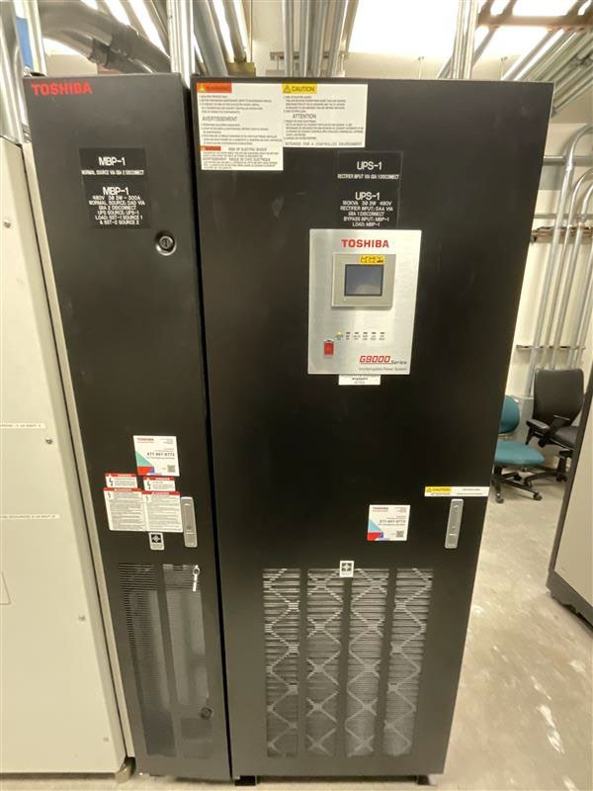

STS CYBERTEX
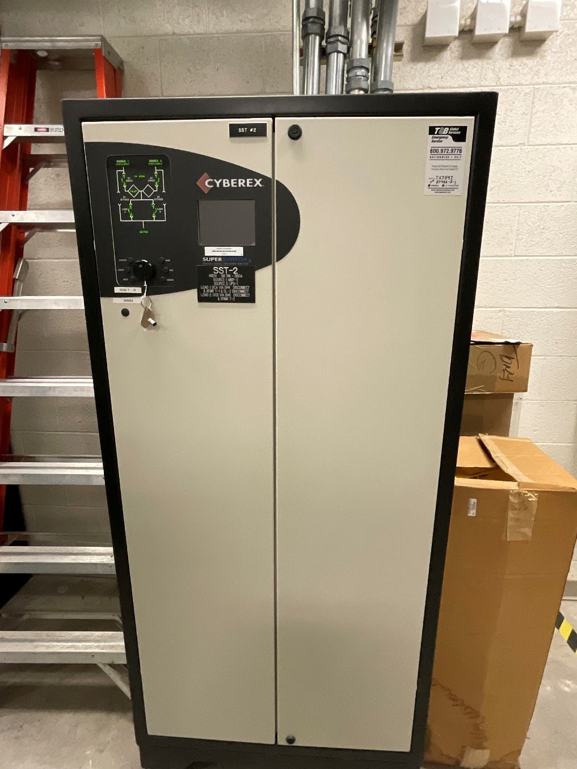

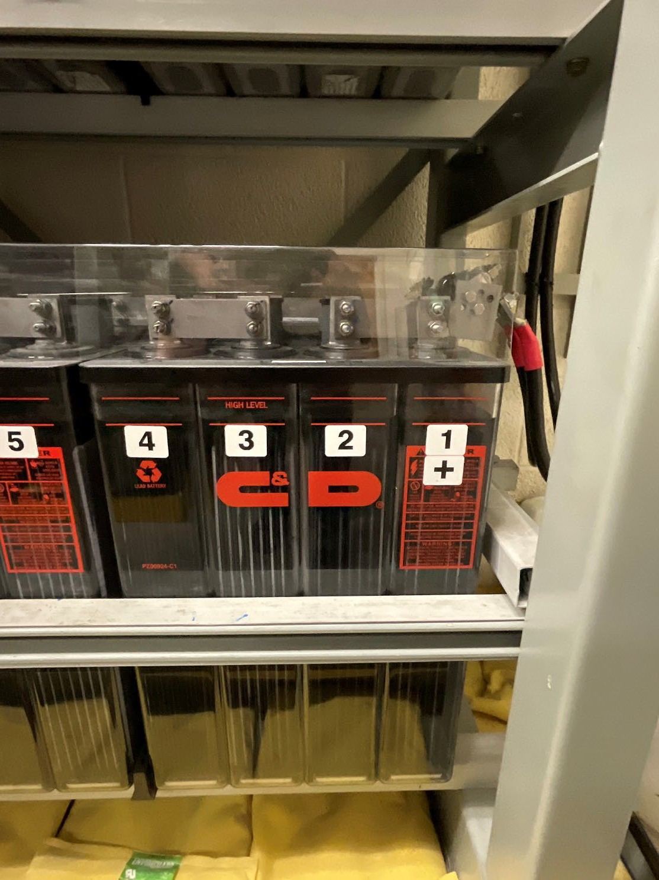
C&D BATTERIES

BAE BATTERIES


